

EVENT CAPTURE V. 2.0

Graphical User Interface (GUI)

Install guide

June 2001

Patch EC*2.0*25

Department Of Veterans Affairs
VistA Systems Design and Development

Revision History

Date | Revision | Description | Author
5/4/01 | 1.0 | Initial Version | Johnny Crosskey
5/7/01 | 2.0 | Updates | J. Morrison
5/8/01 | 2.1 | Updates to section 1.2, 2.2 and 4.0 | T. Laverty
5/10/01 | 2.2 | Updates to sections 2 and 4 | A. Saunders
5/29/01 | 2.3 | Final proofing and updates to section 1.2, 2.2, and 4.3 | J. Crosskey
6/1/01 | 2.4 | Updates to section 2.2 | J. Morrison
12/15/09 | 2.5 | Corrected formatting issues | C. Bailey

Table of Contents
1 Introduction 1
1.1 Purpose 1
1.2 Scope 1
1.3 Acronyms 2
2 Install Requirements 3
2.1 Package Integration 3
2.2 Server Requirements 3
2.3 Client Requirements 3
2.4 Resource Requirements 4
3 Server Installation 5
3.1 Installation Example 6
4 Client Installation 9
4.1 RPC Broker and HOSTS file 9
4.2 Optional Command Line Parameters 12
4.3 ECS GUI Client Installation 12
4.4 Accessing ECS GUI via CPRS: 17
4.4.1 Instructions 17

Introduction

Purpose
The purpose of this Installation Guide is to provide details on the installation of Event Capture System (ECS), Graphical User Interface (GUI) (patch EC*2.0*25), software.

The intended audience of this document includes Technical Services, National VISTA Support and Software Quality Assurance.

Scope
EC*2*25 is the first ECS patch to provide a Graphical User Interface to the ECS application. It offers the current roll-n-scroll functionality in a well-organized and user-friendly GUI environment. This promotes the collection and reporting of accurate workload information to the Decision Support System (DSS). Additionally, ECS GUI will now allow sites to upload patient encounter data from a spreadsheet into Event Capture. The GUI design is consistent in look a feel with current VISTA GUI applications.

ECS GUI offers the following features:
- The user will be able to enter multiple dates/multiple procedures.
- The user will be able to batch enter data by patient.
- The user will be able to batch enter data by procedure.
- The user will be able to access on line help for the software.
- The user will be able to print the following reports:
- Patient Summary Report
- DSS Unit Workload
- Provider Summary Report
- Ordering Section Summary Report
- PCE Data Summary Report
- Inactive Person Class Report
- Procedure Reason Report
- Management users will be able to create/remove current locations.
- Management users will be able to enter/edit DSS Units.
- Management users will be able to assign/remove user access to DSS Units.
- Management users will be able to enter/edit local category.
- Management users will be able to enter/edit local procedure.
- Management users will be able to create event code screens.
- Management users will be able to enter/edit procedure synonym and default volumes.
- Management users will be able to inactive event code screens.
- Management users will be able to activate/inactivate local procedures.
- Management users will be able to activate/inactivate local category.

- Management users will be able to create/print reports.
- National/Local Procedures Report
- Category Report
- Print Category and Procedure Summary
- The user will be able to upload patient encounter data to Event Capture from a spreadsheet.
- The user will be able to switch between CPRS and ECS via the use of a hot button in the tools menu of either application.

Acronyms
ECS Event Capture System
GUI Graphical User Interface
HFS Host File Server
IG Installation Guide
RPC Remote Procedure Call
VA Department of Veterans Affairs
VISTA Veterans Health Information Systems and Technology Architecture

Install Requirements

Package Integration
The following package versions (or higher) must be installed prior to loading this patch of Event Capture:
Kernel 8.0
Toolkit 7.3
Event Capture 2.0
RPC Broker 1.1
MailMan 7.1
VA FileMan 22.0

Server Requirements
Any site not currently running the Event Capture Software application and wishing to install ECS GUI must install all previous EC patches. For details on how to install the previous EC patches, please refer to the corresponding patch descriptions and EC 2.0 Installation guide.

Before generating reports from ECS GUI, a Host File Server directory must be specified at the point where the reports will be temporarily spooled. The directory must be located on the server and have read, write and delete privileges so all ECS users will have the ability to temporarily spool their reports. If you are working against a device file entry, make sure that the entry exists before specifying the directory. This directory functions similarly to a spool printer directory. In fact, you may choose to specify the spool printer’s directory. The directory can be defined during the patch installation or from the ECS GUI Management menu. See Server Installation for an example of specifying this during the patch installation.

Each user will also need to have the option EC GUI CONTEXT added to their secondary menu.

Client Requirements
ECS GUI may be run in a test environment before installation, but it is not necessary. Event Capture runs on the standard hardware platforms used by Department of Veterans Affairs Healthcare facilities. These systems consist of Alpha AXP running DSM, or Alpha/NT running Open M.
To run this Delphi-based application, the following is recommended:

- Intel Pentium 90 or higher (P166 recommended).
- Microsoft Windows 95, 98, or NT 4.0 with Service Pack 3 or later.
- Memory: 32MB of RAM (64MB or more recommended).
- Hard disk space: 6MB.
- VGA or higher resolution monitor.
- Mouse or other pointing device.
- Networks supported: Any Microsoft Windows 95, 98, or Windows NT or higher compatible network.

Resource Requirements
The following resources are part of EC*2.0*25.
Routines 26
RPC 36
Help Frame 18
Option 1
Security Key 1

Server Installation

The following are instructions for installing the Kernel Installation & Distribution System (KIDS) Build of the ECS GUI application. This patch should be loaded during non-peak hours to minimize disruption to users on the system. Installation will take less than 10 minutes.

- Use the INSTALL/CHECK MESSAGE option on the PackMan menu to unload the KIDS distribution.
- Review your mapped set. If any of the routines listed in the ROUTINE SUMMARY section are mapped, they should be removed from the mapped set at this time.
- From the Kernel Installation and Distribution System (KIDS) Menu, select the Installation menu.
- From this menu, you may elect to use the following options (when prompted for INSTALL NAME, enter EC*2.0*25):
- Compare Transport Global to Current System - this option will allow you to view all changes that will be made when the patch is installed. It compares all components of the patch (routines, DDs, templates, etc.).
- Verify Checksums in Transport Global - this option will allow you to ensure the integrity of the routines that are in the transport global.
- Print Transport Global - this option will allow you to view the components of the KIDS build.
- Use the Install Package(s) option and select the package EC*2.0*25.
- When prompted, “Ready to Specify Report Scratch Directory? Yes//”, respond “YES”. You will be prompted for your institution name, and for the HFS scratch directory.
- When prompted, "Want KIDS to INHIBIT LOGONS during install? Yes//", respond "NO".
- When prompted, “Want to DISABLE Scheduled Options, Menu Options, and Protocols? YES//”, respond YES. When prompted to select the options you would like to place out of order, enter the following:
Event Capture Menu ... [ECMENU]
- If a routine was unmapped as part of step 2, it should be returned to the mapped set once the installation has run to completion.
- Upon completion of the installation, place the User and Technical Manual files in a location that can be accessed by all EC users.

Installation Example
Select Installation Option: INstall Package(s)
Select INSTALL NAME: EC*2.0*25 Loaded from Distribution
4/6/01@15:35:19

=> EC*2*25

This Distribution was loaded on Apr 06, 2001@15:35:19 with header of
EC*2*25
It consisted of the following Install(s):
EC*2.0*25
Checking Install for Package EC*2.0*25
Will first run the Environment Check Routine, EC2I25E

Install Questions for EC*2.0*25

In order to run reports from the ECS GUI application you
must specify a scratch directory/path that will be accessible
to all users at your site. You may chose to do this now or
later under the ECS GUI Management Options.

Ready to Specify Report Scratch Directory? Y// ES
Select INSTITUTION NAME: <select your sign-on division>

---- Setting Scratch HFS Directory for Division: <your sign-on division>----
SCRATCH HFS DIRECTORY: <enter your scratch directory here. For example: USER$:[TEST]>

Want KIDS to INHIBIT LOGONs during the install? YES// NO
Want to DISABLE Scheduled Options, Menu Options, and Protocols? YES// <Press Return>

Enter options you wish to mark as 'Out Of Order': ECMENU Event Capture Menu

Enter options you wish to mark as 'Out Of Order': <Press Return>

Enter protocols you wish to mark as 'Out Of Order': <Press Return>

Delay Install (Minutes): (0-60): 0//

Enter the Device you want to print the Install messages.
You can queue the install by entering a 'Q' at the device prompt.
Enter a '^' to abort the install.

DEVICE: HOME// UCX/TELNET
Install Started for EC*2.0*25 :
Apr 06, 2001@15:37:56

Build Distribution Date: Apr 06, 2001

Installing Routines:
Apr 06, 2001@15:37:57
EC*2.0*25
-----------------------------------------------------------------------

Installing PACKAGE COMPONENTS:

Installing SECURITY KEY

Installing REMOTE PROCEDURE
Apr 06, 2001@15:37:58

Updating Routine file...

Updating KIDS files...

EC*2.0*25 Installed.
Apr 06, 2001@15:37:59

Install Message sent #327573

If you specified the HFS directory during the install, you can review the EC Parameter, EC HFS SCRATCH, and update as necessary. From the programmer prompt, do the following:

VAH,ROU>D ^XUP

Setting up programmer environment
Access Code:

Terminal Type set to: C-VT320

>D EN^XPAREDIT

--- Edit Parameter Values ---

Select PARAMETER DEFINITION NAME: EC HFS SCRATCH Scratch HFS Directory
Select INSTITUTION NAME: <Select your sign-on division>

------ Setting EC HFS SCRATCH for Division:ALBANY --------
SCRATCH HFS DIRECTORY: USER$:[SCRATCH]//
Select INSTITUTION NAME: <Press Return>
------------------------------------------------------
Select PARAMETER DEFINITION NAME: <Press Return>

Client Installation

RPC Broker and HOSTS file
RPC BROKER
The assumption is made that the user’s PC has the required RPC Broker Client Workstation set up. If this is not the case, the user should first install this software. The installation is beyond the scope of this installation guide, but the RPC Broker files and installation instructions can be found on the VA’s RPC Broker web page. These files must be installed before running the ECS GUI application.

HOSTS file
A link must be established between the client and the server via the PC's Hosts file and the PC's Windows Registry. The Hosts file (no extension) is in the following:

C:\Windows - for Windows 95 or 98
C:\WinNt\System32\Drivers\Etc - for Windows NT 4

If the Hosts file does not exist, it must be created. (There may be a hosts.sam sample file already in place.) Note that if you create the file with notepad, notepad automatically adds a .txt extension. To remove the extension, use Explorer to rename it, leaving off the .txt.

If the Hosts file already exists, do not delete anything. Follow these instructions for updating the Hosts file:

1. If the user needs to access only one ECS GUI Server, and the ServerPort is 9200, then add a line to the Hosts file, as shown in the example below, using the IP address provided by the server administrator. (There must be at least one space between the address and the name. There can be no spaces in the name itself.)
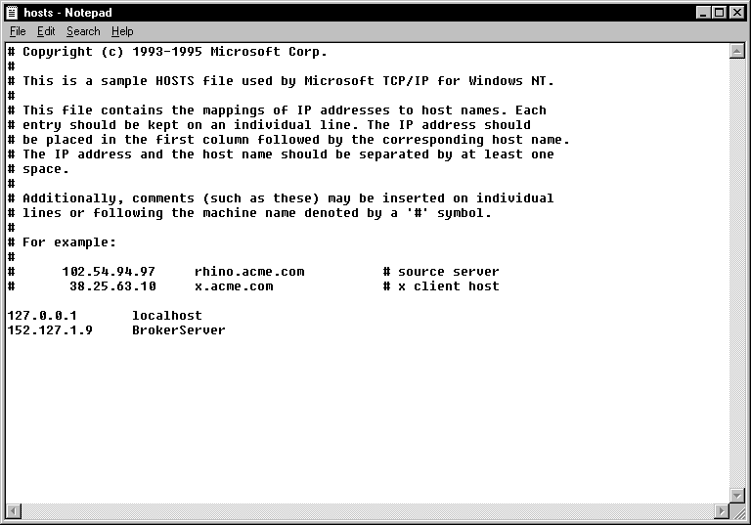

- If the user needs to access only one ECS GUI Server and the ServerPort is not 9200, then add one line to the Hosts file as shown in scenario 1 above, and run the ServerList utility described in scenario 3 below, or use the command line parameters shown in the next section.
- If the user needs to access multiple ECS GUI Servers and/or the ServerPort is NOT 9200, add the ECS GUI Server names to the Hosts file:

      - BrokerServer1 (The names can be anything you like)

152.111.222.444 BrokerServer2
Then run the ServerList Utility, installed via the Custom Installation option of the ECS GUI install package. (If necessary, the ServerList Utility can be installed by re-running the ECS GUI install program and then selecting Custom Installation). The left window of the ServerList utility shows those servers that have been set up as Host Servers in the HOSTS file. The right window shows those servers that have been set up as BrokerServers. To enable a BrokerServer, double-click on the name in the left window to move it to the right window, and then enter the corresponding ServerPort number. (Note: the order of the names in the right list is the order they will be displayed in the drop-down box when starting ECS GUI. If only one server is listed on the right, then you won’t see the drop down box – it will automatically select that server as the default). A left-click in the ‘Del’ column marks and unmarks servers for deletion. See the following ServerList screen print for an example.

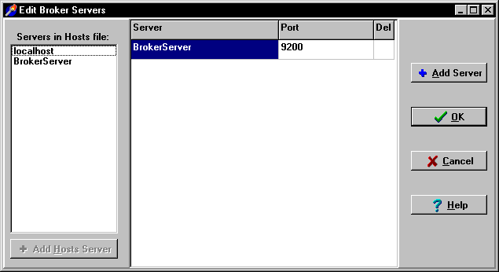

Optional Command Line Parameters
Note: This is required if ECS GUI is not connecting to the BROKERSERVER on PORT 9200 and you choose to not run the ServerList utility.

Note: The parameters may be in any order. Parameters S and P are a set, i.e., they must both be present or they will be ignored.

Parameter Example (Default) Description

S= S=BrokerServer The name of the ECS GUI BrokerServer as defined in the Hosts file.
The default is 'BrokerServer'.
P= P=nnnn The ServerPort used by the ECS GUI BrokerServer.
Example P=9200.

ECS GUI Client Installation
The ECS GUI.exe software can be copied to each PC or accessed on a network drive. Do not place the executable directly on the desktop.

Follow these instructions to install ECS GUI on the client machine.

- Double Click on EC2_0P25.EXE. This will launch the InstallShield Wizard. When
prompted, answer ‘Yes’ to install the ECS GUI application. For some users this screen may not appear. If this is case, the following screen will be the first one that they see.

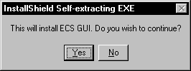
- When the “Welcome” screen is displayed, click "Next".

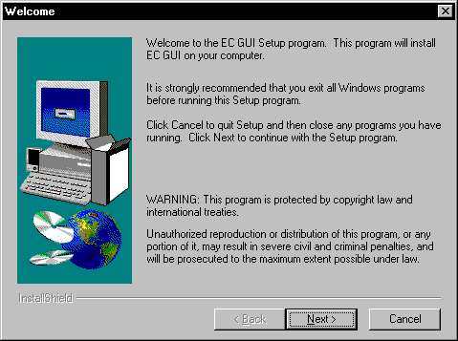

- On the “Choose Destination Location” screen, specify the path using the following format, Drive:\Program Files\VISTA\EC. Click "Next", and the directory will be created.

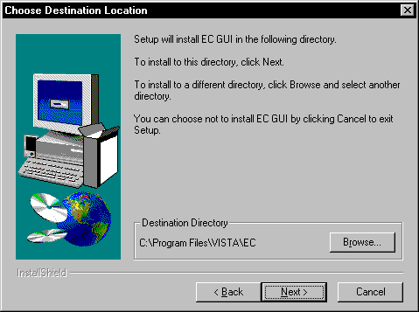
- On the "Setup Type" Screen, select one of the following:
Typical - installs both the ECS GUI client program and ECS documentation.
Compact - installs only the ECS GUI client program.
Custom - allows you to select which programs and files to install, including the RPC Broker ServerList utility and spreadsheet samples (see next screen).

- Typical is selected by default. Click "Next".

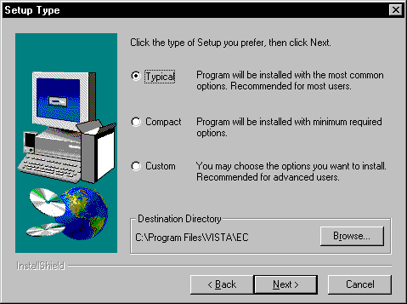

- If you selected the ‘custom’ install, you can select which components you want to install. Click “Next” after you’ve made your selection(s).

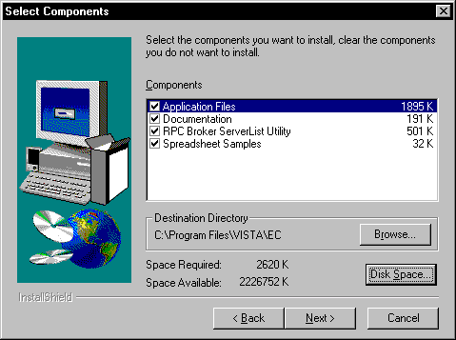

- On the “Select Program Folder” screen, let it default to the ECS GUI program Folder, and click next.

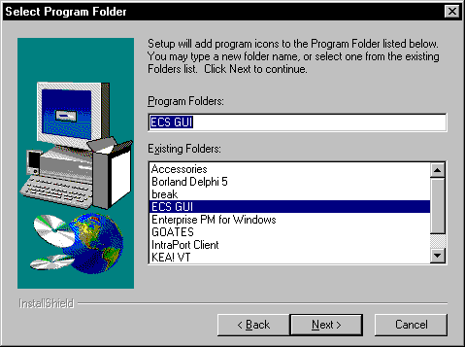
- On the “Start Copying Files” screen, review the information and click "Next.”

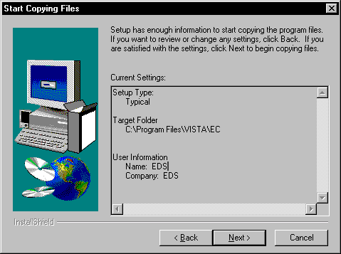

- The ECS GUI will be installed, and the “Setup Complete” screen will be displayed. Click "Finish" and the ECS GUI installation is now complete.

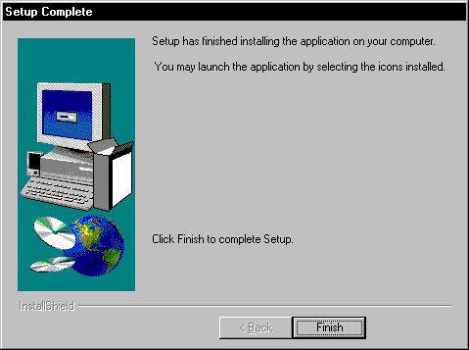
Please note: It is not necessary to re-boot your machine after the installation.

Accessing ECS GUI via CPRS
It is possible to set up a “hot button” that will allow you switch back and forth between the CPRS and ECS applications. The button can be placed in the Tools menu of CPRS GUI. Within CPRS, the Tools menu is a place where you can place items that you want to have quick access to when within this application. These items can include other parts of VistA, such as ECS.

A button that will allow a user to access ECS GUI in the CPRS Tools Menu can be created for all CPRS users or a specific user by the site’s clinical coordinator. He/She must create this button in VistA.

Instructions

Note: Parentheses denotes abbreviations that can be entered instead of entering the full name of the option.
- From the CPRS Configuration Menu for Clinical Coordinators enter GUI Parameters (GP) at the prompt.
- From the list of options given, enter GUI Tool Menu Items (TM) at the prompt.
- From the list of options given, enter Package (9). Note: By choosing this option you are giving this functionality to all users. If you want to give this functionality to one user choose User (1) instead.
- The user will receive two messages. One regarding the parameters set for ‘Package’ and the other for the Setting of the CPRS GUI Tools Menu for Package.
- The user will be asked to select a sequence. Type a question mark to get a choice of options.
- Enter a number higher than the last option to add a new option.
- When asked if you are adding a new option, enter yes.
- When prompted for a “Name=Command” enter: &Event Capture="c:\program files\vista\ec\ecs gui.exe"
- When asked to select a sequence again, press ‘enter’ to get out of prompt.
Example

AU Auto-DC Parameters
AL Allocate OE/RR Security Keys
KK Check for Multiple Keys
DC Edit DC Reasons
GP GUI Parameters ...
MI Miscellaneous Parameters
NO Notification Mgmt Menu ...
OC Order Checking Mgmt Menu ...
MM Order Menu Management ...
LI Patient List Mgmt Menu ...
FP Print Formats
PR Print/Report Parameters ...
RE Release/Cancel Delayed Orders
US Unsigned orders search
EX Set Unsigned Orders View on Exit
NA Search orders by Nature or Status

Select CPRS Configuration (Clin Coord) Option: GP GUI Parameters

CS GUI Cover Sheet Display Parameters ...
HS GUI Health Summary Types
TM GUI Tool Menu Items
MP GUI Parameters - Miscellaneous
UC GUI Clear Size & Position Settings for User
RE GUI Report Parameters ...

Select GUI Parameters Option: TM GUI Tool Menu Items

CPRS GUI Tools Menu may be set for the following:

1 User USR [choose from NEW PERSON]
2 Location LOC [choose from HOSPITAL LOCATION]
2.5 Service SRV [choose from SERVICE/SECTION]
3 Division DIV [choose from INSTITUTION]
4 System SYS [PERF.ISC-BAYPINES.VA.GOV]
9 Package PKG [ORDER ENTRY/RESULTS REPORTING]

Enter selection: 9 Package ORDER ENTRY/RESULTS REPORTING

Parameters set for 'Package' may be replaced if ORDER ENTRY/RESULTS REPORTING is installed in this account.

-- Setting CPRS GUI Tools Menu for Package: ORDER ENTRY/RESULTS REPORTING --
Select Sequence: ?
Sequence Value
-------- -----
1 &Time=Clock.exe
2 &Calculator=Calc.exe
3 &Windows Introduction=WinHlp32 Wind
4 &Notepad=Notepad.exe

Select Sequence: 5
Are you adding 5 as a new Sequence? Yes// YES

Sequence: 5// 5
Name=Command: &Event Capture="c:\program files\vista\ec\ecs gui.exe"

For more information on this “tools” option, consult the CPRS user guide at
http://vista.med.va.gov/VistA_Lib/Clinical/Comp_Patient_Recrd_Sys_(CPRS)/cprsguium.pdf

This installation installs the GUI executable on the user’s workstation at location: C:\Program Files\VISTA\EC (unless another directory was specified on the “Choose Designation Location” screen). Using Windows or NT Explorer, go to the directory location of the executable (on the user’s workstation), create a Shortcut, and paste or copy it to the user’s Desktop for convenient access to the application.

If any prior versions of the applications exist on in the user’s directory location referenced above, these should be deleted.

